Microservices with Spring Boot 3 and Spring Cloud OUTPUTS

1. Creating Microservices for account and loan

**Step – 1 :** Go to spring initializr and create a maven project.

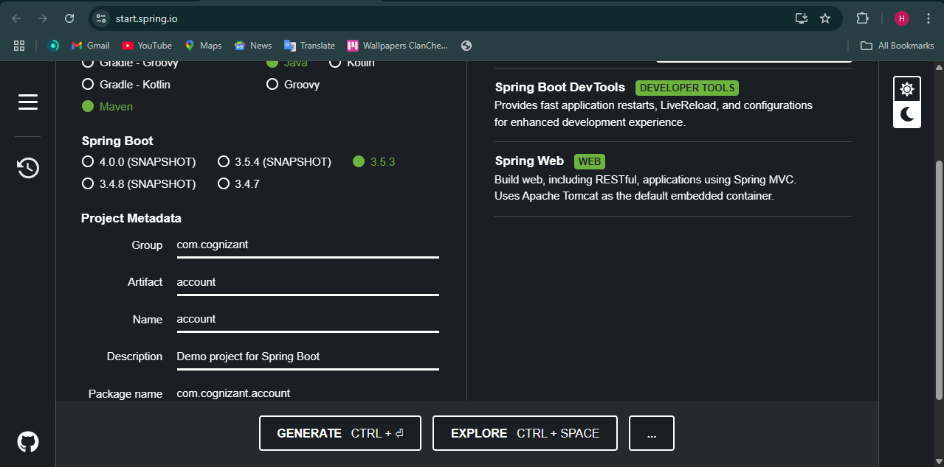

**Step – 2 :** Import the file in eclipse.

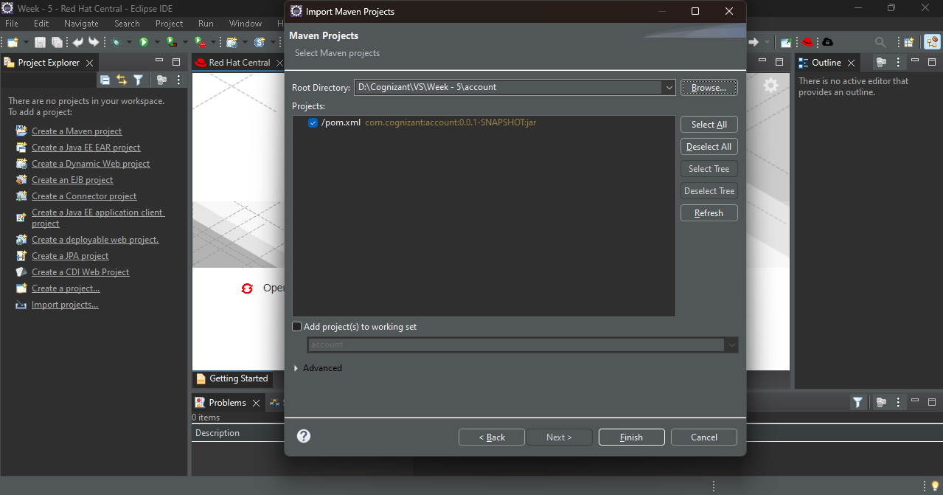

**Step – 3 :** Create AccountController.java class in com.cognizant.account package.

**Code :**

package com.cognizant.account;

import org.springframework.web.bind.annotation.*;

@RestController

public class AccountController {

@GetMapping("/accounts/{number}")

public Account getAccountDetails(@PathVariable String number) {

return new Account(number, "savings", 234343);

}

}

class Account {

private String number;

private String type;

private double balance;

public Account(String number, String type, double balance) {

this.number = number;

this.type = type;

this.balance = balance;

}

public String getNumber() { return number; }

public String getType() { return type; }

public double getBalance() { return balance; }

}

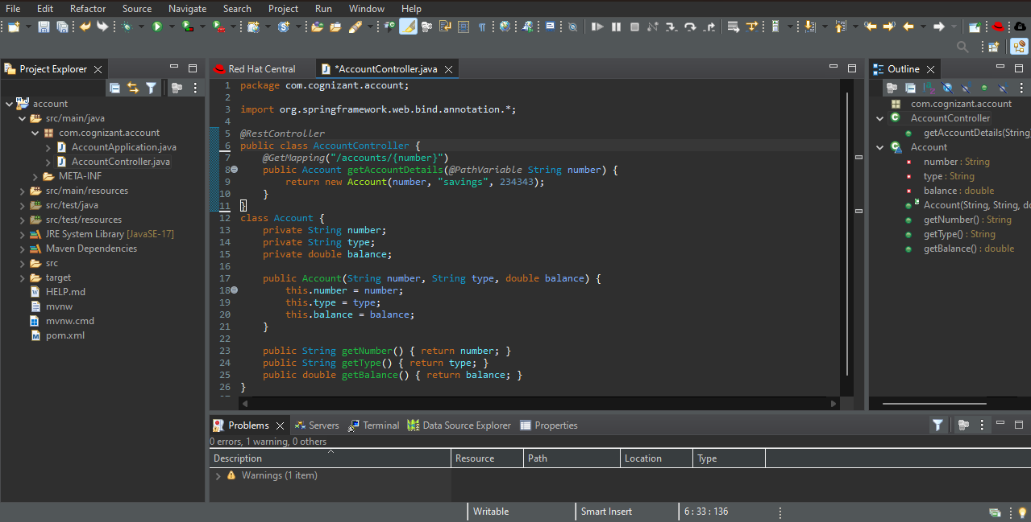

**Step – 4 :** Now go to spring initializr and create a another project loans.

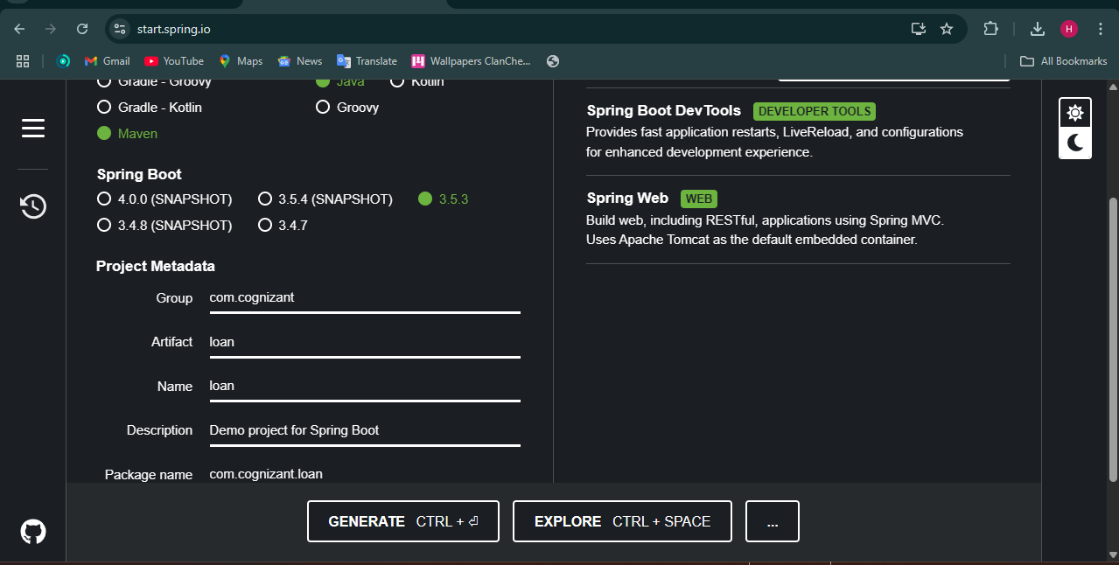

**Step – 5 :** Import the project in eclipse.

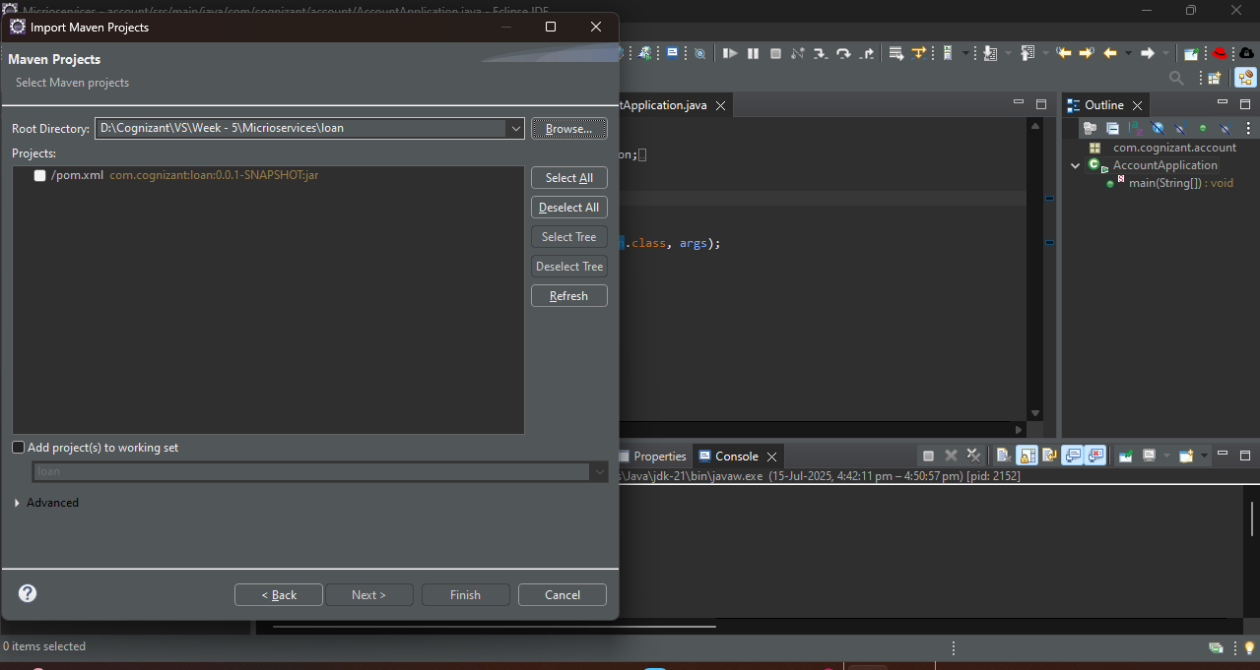

**Step – 6 :** Go to src/main/resources/application.properties and enter our port number.

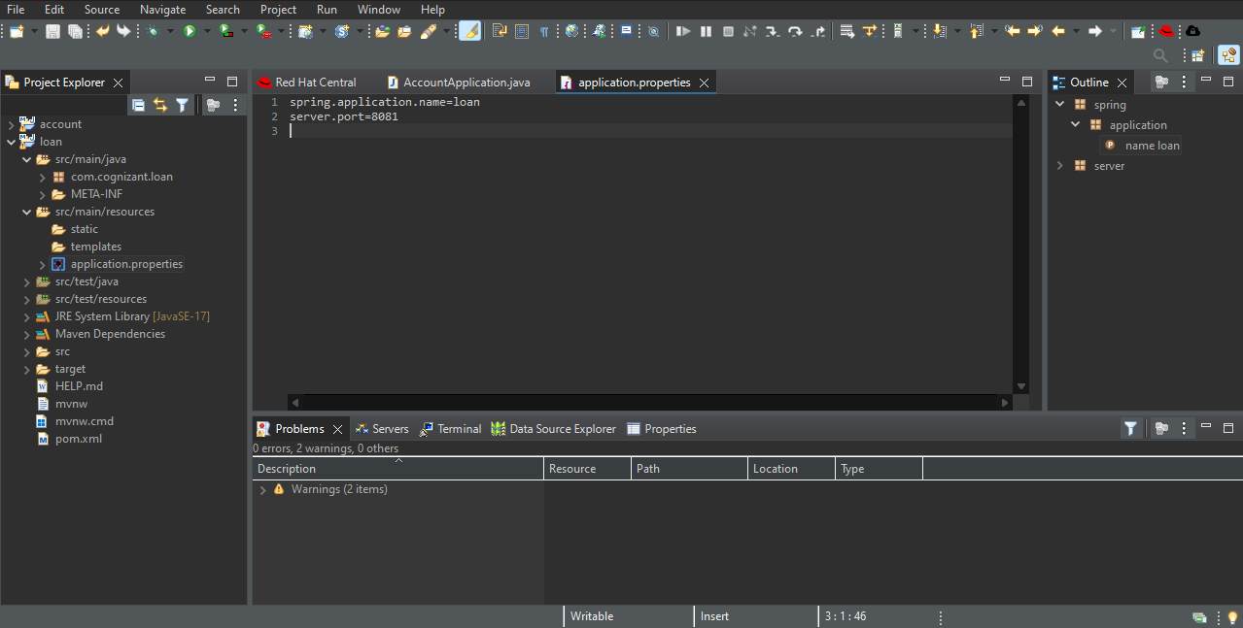

**Step – 7 :** Create LoanController.java in com.cognizant.loan package.

**Code :**

package com.cognizant.loan;

import org.springframework.web.bind.annotation.*;

@RestController

public class LoanController {

@GetMapping("/loans/{number}")

public Loan getLoanDetails(@PathVariable String number) {

return new Loan(number, "car", 400000, 3258, 18);

}

}

class Loan {

private String number;

private String type;

private double loan;

private int emi;

private int tenure;

public Loan(String number, String type, double loan, int emi, int tenure) {

this.number = number;

this.type = type;

this.loan = loan;

this.emi = emi;

this.tenure = tenure;

}

public String getNumber() { return number; }

public String getType() { return type; }

public double getLoan() { return loan; }

public int getEmi() { return emi; }

public int getTenure() { return tenure; }

}

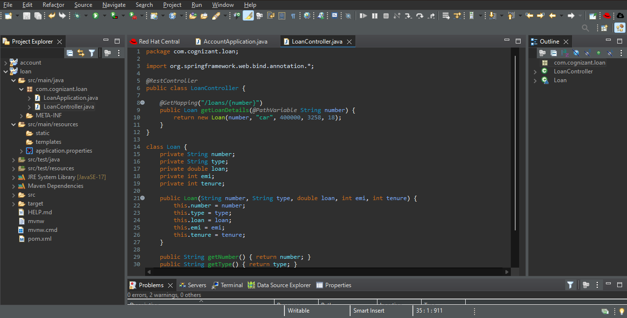

**Step – 8 :** Run LoanApplication.java as java application.

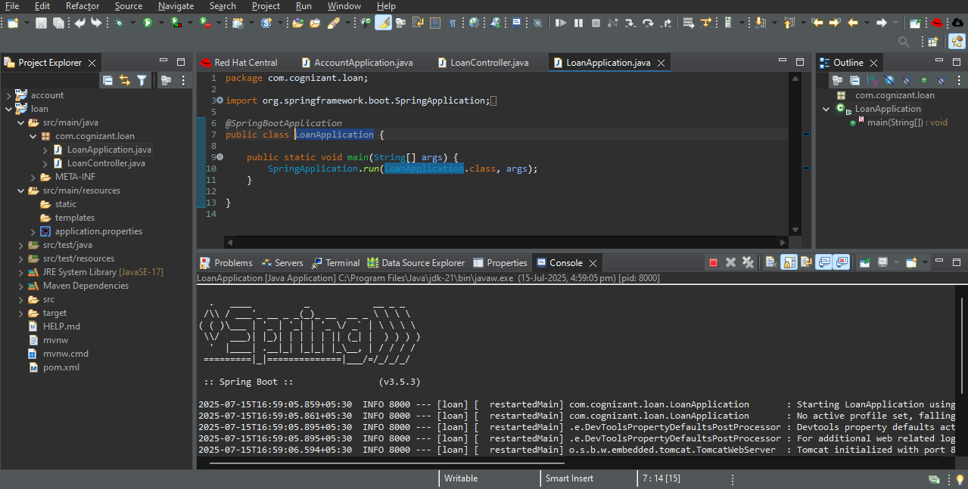

**Step – 9 :** Go to AccountApplication.java and run it as java application.

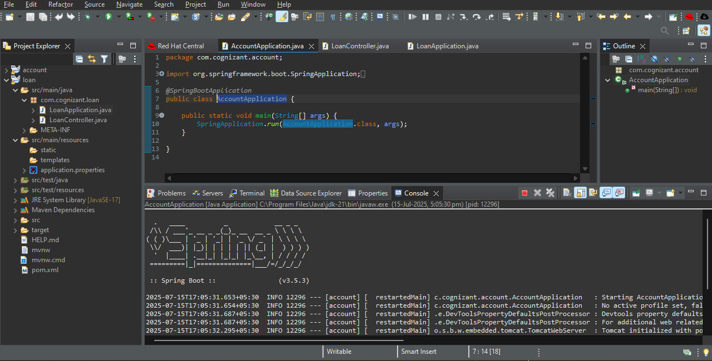

**Step – 10 :** Go to postman and run

1. <http://localhost:8080/accounts/00987987973432>
2. <http://localhost:8081/loans/H00987987972342>

Make sure you enter different port numbers for both applications.

OUTPUT :

1. 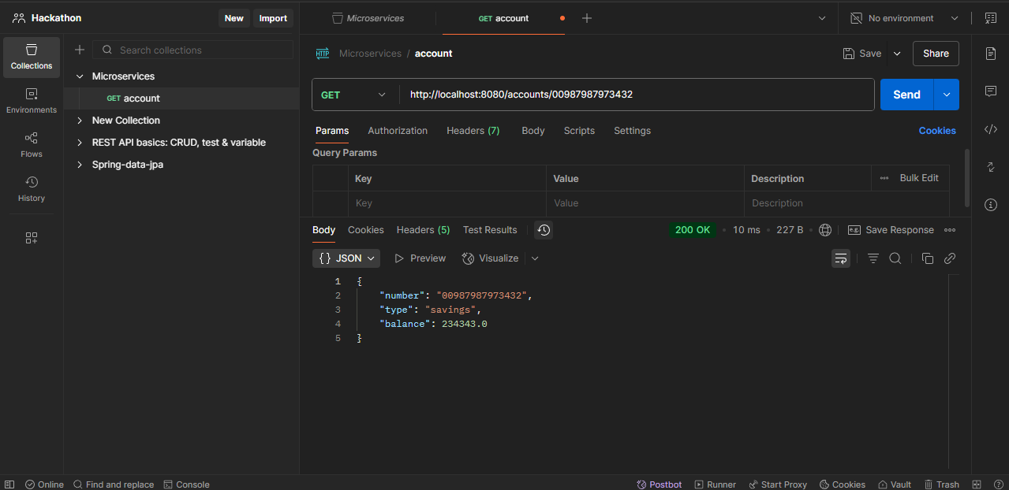

2.

